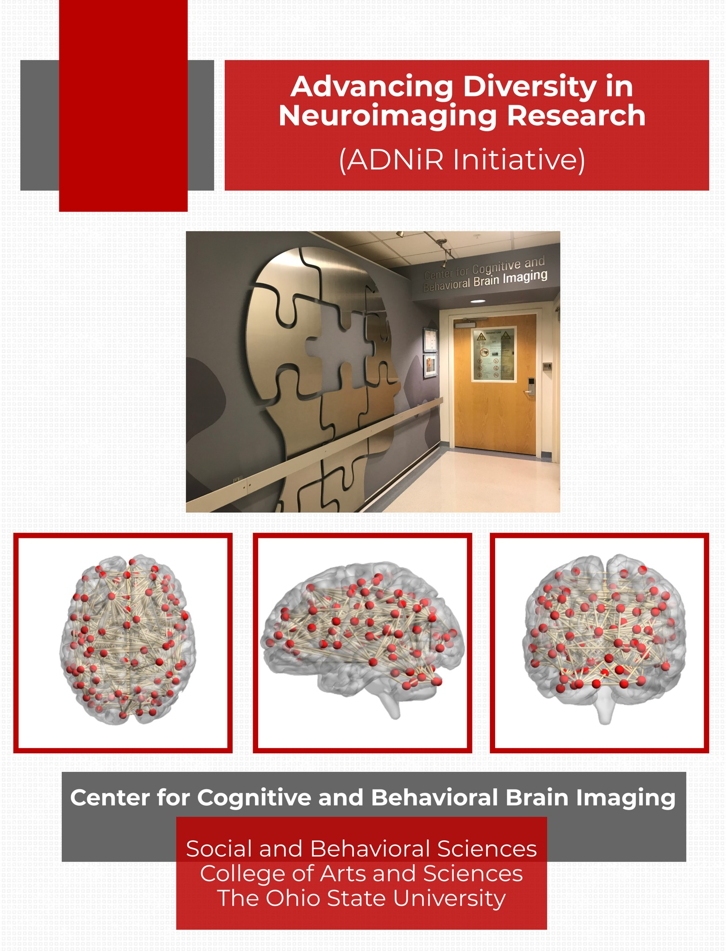
1

Table of Contents

Mission Statements 2
Statement of Purpose 3
Long term Goals and Overall Objective 4
General Guidelines 5
Expectations of Recipient 6
Application Process 6
Responsibilities of Principal Investigator 7
Proposed Timeline 7
CCBBI Affiliated Laboratories 10
References 11

Mission Statements

College of Arts and Sciences:

“The College of Arts and Sciences affirms that academic excellence depends upon recruiting and supporting a diverse population of faculty, staff, and students and on encouraging this diverse faculty to pursue innovative research, transformative teaching and learning, and engaged outreach. Diversity is everyone’s goal, everyone’s priority, and to everyone’s benefit. The College is therefore committed to actively building and sustaining a community in which people of diverse race, ethnicity, culture, veteran status, marital status, socio-economic level, citizenship, national origin, religious belief, physical ability, sexual orientation, gender identity and expression, age, class, and political ideology fully participate in, contribute to, and benefit from the resources and activities of its departments, centers, and programs.
Moreover, the College is committed to promoting the university’s policies against discrimination and to increasing the participation of individuals from historically underrepresented groups at all levels, including within its administration.” (OSU College of Arts and Science Strategic Plan, 2011-2016)

Center for Cognitive and Behavioral Brain Imaging:

“The Center for Cognitive and Behavioral Brain Imaging is dedicated to pursuing structural and functional magnetic resonance studies using state-of-the-art techniques, to contribute to the development of future brain imaging modalities, and to disseminate knowledge about brain, mind, and imaging to students and the public.”

Statement of Purpose

The Center for Cognitive and Behavioral Brain Imaging (CCBBI) recognizes the critical need for a more diverse body in academia, science, and research. To afford the opportunity of success for all individuals, CCBBI is proposing the Advancing Diversity in NeuroImaging Research Initiative (ADNiR) to provide academic opportunities, professional development, and funding support, with a focus on individuals from underrepresented groups who are interested in pursuing a career in neuroimaging research.

As part of the Center for Cognitive and Behavioral Brain Imaging’s commitment to developing future generations of neuroimaging researchers, the ADNiR Initiative offers pathways to success in neuroimaging research focused on undergraduate students from underrepresented groups. The program aims to eliminate potential obstacles in a student’s academic success and professional development by providing hands-on research experiences in CCBBI-affiliated neuroimaging laboratories. The ADNiR Initiative recognizes the importance of formal training in several aspects of professional development; thus, an integral component of the ADNiR program will be to provide students with professional guidance and financial support for applying to graduate schools in their relevant area of study.

Great efforts have been made to make higher education accessible to everyone, however within the scientific community individuals from diverse groups are still underrepresented, with an even greater disparity in the research community. Although more than 30 years have passed since the academic imparity between ethnic groups was first identified, academic opportunities continue to remain out of reach for many individuals from underrepresented groups (Garrison, 2013). This imbalance increases in graduate school and continues to widen in the workforce. A study conducted by Li and Koedel (2017) reported diversity among faculty continues to be imbalanced with a majority of faculty members identifying with one ethnic group. There may be several reasons that factor into the disparity of students who choose a career path in academia or science; however, for many individuals the challenge may be having to choose to work instead of committing time, often voluntarily, in a research setting. Other challenges may be related to a cultural background that did not afford the same opportunities across genders or simply not being aware of the opportunity if the individual is a first- generation college student. A review by Estrada et al. (2016) identified these factors as significantly impacting the academic outcomes of these student populations. Removing some of these obstacles is the goal of the ADNiR Initiative.

Long Term Goals & Overall Objective

The long-term goal of the ADNiR Initiative is to create a community of neuroimaging researchers that is representative of the nation’s growing diversity to help foster a better understanding of the brain. To achieve that goal, the overall objective is to provide structured, hands-on research experiences and tailored professional development opportunities focused on undergraduate students from underrepresented groups. To accomplish this overall objective, the CCBBI supported ADNiR initiative will provide two fundamental experiences:

- Hands-on Research Experiences: In collaboration with CCBBI-affiliated laboratories, students selected through this program will be offered an opportunity to do a one-month lab rotation in three laboratories to provide exposure to a broader variety of neuroimaging research being conducted at OSU. This will be followed by a two-year, funded, Research Assistant (RA) position in one of the three laboratories decided mutually by the undergraduate student and the Principal Investigator (PI) of the laboratory. The latter experience is specifically designed to provide the student with direct, in-depth training in all aspects of neuroimaging research, from data acquisition through data analyses, to eventual dissemination of brain imaging research through peer-reviewed publication(s).

- Tailored Professional Development Opportunities: Throughout the two-year period, students will be afforded several opportunities that will be specifically tailored to meet their goal of pursuing a graduate program in their field of study. Specifically, the following opportunities will be provided to all students enrolled in the ADNiR Initiative: weekly seminars focusing on topics and techniques in cognitive neuroscience; monthly CCBBI Talk Series Meetings; monthly CCBBI Student Workshop meetings; and financial support of $1000 per year to attend and present at a national and domestic conference. Additional opportunities will be carved out in discussion with CCBBI Director, Dr. Prakash, the PI of the respective laboratory, and the undergraduate student.

General Guidelines and Eligibility

- The opportunity is open to undergraduate students interested in pursuing a career in neuroimaging research. Students from underrepresented groups and diverse backgrounds are strongly encouraged to apply.

- Applicants majoring in any of the disciplines supported by the College of Arts & Sciences, including but not limited to Psychology, Economics, Speech & Hearing Sciences, Communication, and Music are eligible to apply. Additionally, undergraduate students from other colleges at OSU will be considered as long as they choose to conduct their research in a CCBBI-affiliated lab.

- Applicants who are enrolled as a college student and completed at least 3 semesters of college, (ie: second semester Sophomore), with a GPA of 3.1 or higher will be invited to apply for the program.

- Student’s commitment to the ADNiR Initiative will last for 2 years.

- Students will be expected to work 15-20 hours per week in a research lab and will be paid an hourly rate as determined by College HR.

- Each student will receive 2 years of financial support from CCBBI. This will include paid hourly positions in a CCBBI-affiliated laboratory and travel to a domestic conference to present neuroimaging research.

- Mentorship and professional development will be provided by a participating PI conducting research at CCBBI.

- Students must attend weekly Cognitive Neuroscience Proseminars and bi-weekly CCBBI meetings. These meetings are designed to provide peer support and sharing of information to promote academic and professional success.

Expectations of Recipient

Often times an obstacle to exploring undergraduate research assistant opportunities is having to choose to work to pay the bills as most undergraduate research lab positions are for college credit. To eliminate the financial obstacle, students accepted into the program will be enrolled for a period of two years receiving financial support from CCBBI. The program will require students to work 15-20 hours per week as a paid undergraduate research assistant. A longitudinal study by Hernandez et al. (2018) reported that students working at least 10 hours a week in a research lab for at least two semesters had significantly higher acceptance rates into graduate school and greater participation in a scientific related career. Since each lab has different theoretical perspectives and expectations, students will interview with the PIs of each participating lab to determine the best fit for the student’s goals and interests. For the first summer in the program, students will participate in a lab rotation in which they will spend one month assisting in a participating lab to help them determine which lab is the best fit for them. After the summer rotation, students will be matched with a PI, joining their lab as a research assistant for a period of two years. Students will be expected to learn how to design and conduct a research study, which includes data collection, data analysis and co-authorship on a peer-reviewed manuscript. At the end of their undergraduate program, students will give a presentation to the students and faculty of the ADNiR Initiative.

Application Process

For students interested in applying to the ADNiR Initiative, please email Adam Sharp at ccbbi.service@osu.edu with a copy of the application and your unofficial transcript. If you are simply interested in discussing the ADNiR Initiative, please email the CCBBI Director, Dr. Ruchika Prakash, at prakash.30@osu.edu.

Responsibilities of Principal Investigator

All research laboratories conducting studies at CCBBI will be invited to participate in the program. Mentorship has been identified as an essential factor for successful academic outcomes in students from underrepresented groups (Hernandez et al., 2018; Kaba, 2013). Participation will require PIs to mentor students to achieve academic success and prepare students for continued success.

Mentorship Expectations:
- Identify a graduate student and/or post-doctoral scientist in their lab to provide direct mentorship to the undergraduate student. The lab mentor will advise student(s) through weekly meetings to provide training in data acquisition, designing of neuroimaging studies, and neuroimaging analyses. Additionally, the lab mentor in collaboration with the PI, will also provide support and encourage personal and professional growth, including identifying and working through challenges the student may experience.

- Establish guidelines, clearly communicate the expectations of the student’s employment as an undergraduate research assistant, and provide evaluation to ensure student is receiving the guidance and support needed to succeed.

- Provide updates to the CCBBI Director regarding the student’s progress on an annual basis.

Proposed Timeline

The proposed date for accepting applications will be February 2021 with an enrollment date of June 2021. As this is a new program, promotion of the opportunity across the OSU campus will begin during the later Autumn 2020 semester. The goal of the program is to enroll 1-2 new students each year, with a maximum of six mentees enrolled at one time, to ensure the students are receiving the support and training necessary for achieving academic and professional success.
Action | Timeline | Result
Preparation to Launch ADNiR
Establish ADNiR Initiative | Autumn 2021 | Funding secured by CCBBI  Participation of at least 4 research labs
Promote ADNiR Initiative to undergraduate students | October – December 2021 | Present funding opportunities to student groups and academic advisors
ADNiR Open Applications/ Onboarding of Recipients
Submission of applications | November 15 -  January 26
Interview applicants | January 2022 | Interviewers are Dr. Prakash and PIs participating in the program
Funding opportunity awarded to applicants | February 2022 | 1-2 students accepted into the program each year
Students meet with CCBBI | March 2022
Students meet with PIs | March 2022 | Faculty and students meet to determine best fit
ADNiR Class of 2024 Begins
ADNiR Program begins | July –  August 2022 | Students begin rotation in three different labs
ADNiR Placement | September 2022 | Two-year placement in a CCBBI-affiliated laboratory
Start of Professional Development Opportunities | September 2022 | Attendance at CCBBI Users’ Meetings and Cognitive Neuroscience Proseminars
GRE preparation | Spring 2023
GRE exam | Summer -  Autumn 2023
Graduate school applications | Autumn 2023
Research experience presentations | Spring 2024
Graduate school interviews and acceptance | Spring 2024
Graduation | May 2024 | Successful completion of ADNiR Program
Proposed Timeline for AY ’21-‘22

CCBBI-Affiliated Laboratories

CCBBI PI | Research Interests | Current Projects
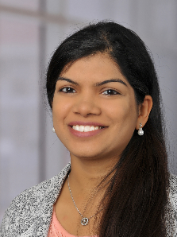  Jewel Crasta, Ph.D., OTR/L  Assistant Professor in the School of Health and Rehabilitation Sciences  Faculty Web Page | Our research focuses on examining the relationship between attention and sensory processing in children and young adults with autism spectrum disorders using neuroimaging tools such as electroencephalography (EEG) and functional magnetic resonance imaging (fMRI) along with performance-based measures. Additionally, we work with children with traumatic brain injury, sports-related concussion, and attention-deficit hyperactivity disorder (ADHD) examining brain-behavior relationships. | - Sensory processing in autism spectrum disorders  - Brain-behavior relationships using EEG and fMRI in children with neurodevelopmental disorders  - Attention interventions in Occupational Therapy
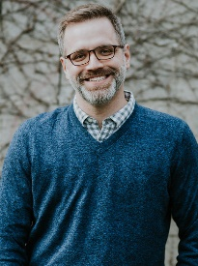  Jay Fournier,  Ph.D.  Associate Professor in the Department of Psychiatry and Behavioral Health;  Director of the Mood and Anxiety Program;  Co-director of the Division of Cognition and Emotion  Faculty Web Page | Our research program focuses on identifying patient characteristics that are associated with differential response to treatments for depression and related disorders. In addition, our work investigates the neural and behavioral mechanisms through which those characteristics either facilitate or inhibit response to relevant treatments. As such, our research bridges work in clinical interventions, mood disorders, personality and neuroscience. | - Functional neuroanatomy of depression, anxiety, and other disorders of negative affect  - Links between dimensions of negative affect and functioning in everyday life  - Predictors and mechanisms of differential response to treatments for mood and anxiety disorders  - Development and refinement of individualized treatment strategies
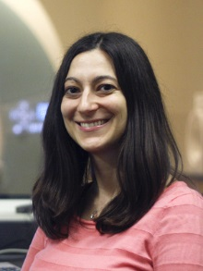  Julie Golomb, Ph.D.  Associate Professor of Psychology  Vision and Cognitive Neuroscience Lab | The Vision & Cognitive Neuroscience lab explores the interactions between visual attention, memory, perception, and eye movements using human behavioral and computational cognitive neuroscience techniques. We focus on how objects and their spatial locations are perceived and coded in the brain, and how these representations are influenced by eye movements, shifts of attention, and other top-down factors | - Neural representations of 3D visual space.  - Reconstructing the contents of visual working memory.  - How dynamic attention influences visual feature representations.
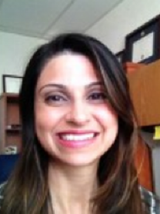  Jasmeet Hayes, Ph.D.  Associate Professor of Psychology  The Mindset Lab | The MINDSET lab (MRI Investigation of Neurodegenerative Disease, Stress Effects and Traumatic brain injury) is a research laboratory dedicated to studying the long-term effects of traumatic brain injury and psychological stress on the brain, cognition, and broader health outcomes. We use neuroscience tools such as Magnetic Resonance Imaging including structural T1-weighted imaging, diffusion tensor imaging, and fMRI to examine potential links between trauma and neurodegenerative disease. | - Understanding the effects that traumatic brain injury (TBI) and psychological stress have on the human brain and health outcomes  - Examine how genetic and epigenetic factors moderate outcomes after injury and through the aging process  - Investigates the long-term consequences of injury to the brain, including links to neurodegenerative diseases such as Alzheimer’s disease, and interactions with mental health disorders
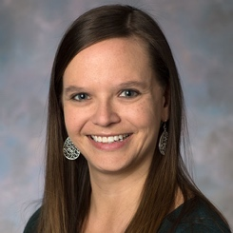  Kristen Hoskinson, Ph.D.  Assistant Professor in the Cancer Control Program at the OSUCCC – James  Faculty Web Page | As a member of the Cancer Control Program at the OSUCCC – James, I focus my research on pediatric neuropsychology with an emphasis on improving the understanding of cognitive, emotional and behavioral conditions that result from neurologic injury, such as pediatric brain tumors. In particular, I integrate neuroimaging methods with social and emotional functioning to improve early identification of children at elevated risk who can benefit greatly from intervention. | - Explore the neuroanatomical and functional correlations of social and adaptive difficulties in children who have been treated for pediatric brain tumors.
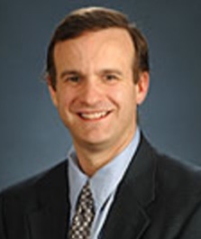  Stephen Petrill, Ph.D.  Professor of Psychology  The Western Reserve Reading Project | The Western Reserve Reading Project is a longitudinal study that has been funded by the National Institutes of Health and Child Development of the NIH. Presently, we have around 450 pairs of twins who have participated in annual data collection sessions over the past 15 years. This was the first time any study integrated brain scanning to understand how genetic and environmental differences affect how and where people process reading and math skills in the brain. | - Examine the genetic and environmental contributions to the development of cognitive skills related to reading, mathematics, language, and attention.
Ruchika Prakash, Ph.D.  Associate Professor of Psychology  Director, CCBBI  Clinical Neuroscience Lab | Understanding neuroplasticity in the context of healthy aging and neurological disorders, specifically multiple sclerosis, and applying the knowledge gained through research in basic sciences to design interventions that tap into such neuroplasticity. | - Mindfulness meditation and its impact on neural and behavioral correlates of sustained attention in older adults.  - Impact of physical activity intervention on working memory connectome of people with MS.  - Deriving a functional connectivity-based biomarker of Alzheimer’s Disease pathology.
Zeynep Saygin, Ph.D  Assistant Professor of Psychology  Z-Lab | The Z-Lab studies Developmental Cognitive Neuroscience. We use longitudinal neuroimaging and computational modeling to investigate the developing human brain, answering questions like: What are the brain building blocks that we are born with, how do they change with maturation and experience, and can we use this information to predict the development of individual abilities later in life?
Dylan Wagner, Ph.D.  Associate Professor of Psychology  The Wagner Lab | Research in the lab is primarily focused on investigating the brain basis of how humans take disparate facts and observations about other persons and weave these into the complex and multidimensional character portraits that form the basis of our person knowledge. A separate topic of research focuses on examining the behavioral and neural mechanisms of self-regulation and its failure.
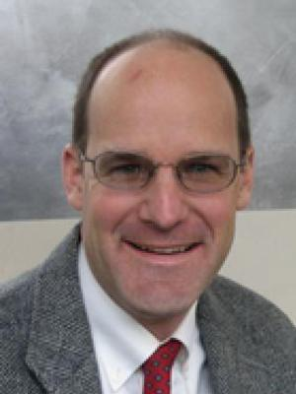  Baldwin Way, Ph.D.  Associate Professor of Psychology  Social Neurochemistry Lab | Our lab studies the psychological and neural mediators of the bidirectional influences between the immune system and social and emotional behavior. | - Geospatial exposures to violence and neural effects on threat and reward processing (link).  - Effect of anti-inflammatory drugs on emotional processing.  - Effects of inflammatory challenge on socio-emotional processing.

References

- Estrada, M., Burnett, M., Campbell, A.G., … Zavala, M.E. (2016). Improving underrepresented minority student persistence in STEM. CBE-Life Sciences Education, 15, 1-10. DOI: 10.1187/cbe.16-01-0038
- Garrison, H. (2013). Underrepresentation by race–ethnicity across stages of U.S. science and engineering education. CBE—Life Sciences Education, 12, 357–363. DOI: 10.1187/cbe.12-12-0207
- Hernandez, P.R., Woodcock, A., Estrada, M. and Schultz, P.W. (2018). Undergraduate research experiences broaden diversity in the scientific workforce. BioScience, 68, 2014-2011. DOI: 10.1093/biosci/bix163
- Kaba, A.J. (2013). Black Americans, gains in science and engineering degrees, and gender. Sociology Mind, 3, 67-82. DOI: 10.4236/sm.2013.31012
- Li, D. and Koedel, C. (2017). Representation and salary gaps by race-ethnicity and gender at selective public Universities. Educational Researcher, 46, 343 –354. DOI: 10.3102/0013189X17726535
- National Science Foundation. (2019). NCSES women, minorities, and persons with disabilities in science and engineering. https://ncses.nsf.gov/pubs/nsf19304/digest/introduction. Retrieved September 27, 2019.

